NAME: KAVITAPU SWARNA VARSHINI
REG.NO: 192324081
DATE: 14-07-2026

Write a python program for cript-arithmetic problem
AIM: To write a Python program to solve the Crypt-Arithmetic Problem by assigning unique digits to letters such that the arithmetic equation is satisfied.
ALGORITHM:
- Define the crypt-arithmetic equation (e.g., SEND + MORE = MONEY).
- Identify all unique letters involved in the equation.
- Generate all possible digit assignments without repetition.
- Check whether the assigned digits satisfy the arithmetic equation.
- Display the correct digit assignment as the solution.
CODE:
from itertools import permutations
letters = ('S','E','N','D','M','O','R','Y')
for p in permutations(range(10), 8):
S,E,N,D,M,O,R,Y = p
if S == 0 or M == 0:
continue
SEND = 1000*S + 100*E + 10*N + D
MORE = 1000*M + 100*O + 10*R + E
MONEY = 10000*M + 1000*O + 100*N + 10*E + Y
if SEND + MORE == MONEY:
print("SEND =", SEND)
print("MORE =", MORE)
print("MONEY =", MONEY)
break
OUTPUT:
SEND = 9567
MORE = 1085
MONEY = 10652
IMAGE:
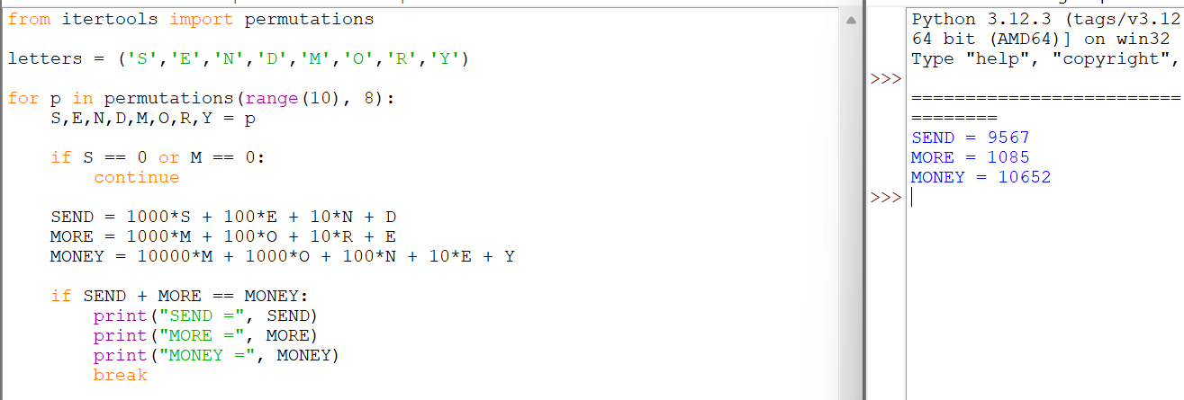

RESULT:
The Python program successfully solved the Crypt-Arithmetic Problem by assigning unique digits to each letter and verifying the arithmetic equation.

